**Detailed Software Technical Design (DSTD)**

**For**

VYNTRAMART

**TABLE OF CONTENTS**

**1** **INTRODUCTION**

1.1 Purpose

1.2 Scope

1.3 Definitions, Acronyms and Abbreviations

1.4 References

**2** **ASSUMPTIONS**

**3** **PROJECT OVERVIEW AND USECASE DIAGRAMS**

**4**  **SEQUENCE DIAGRAM**

**5 CLASS DESIGN**

**6** **Entity Relationship Diagrams**

7 **State Chart Diagram**

**Document Revisions**

|  |  |  |  |  |  |
| --- | --- | --- | --- | --- | --- |
| **Date** | **Version** | **Description** | **Author** | **Reviewer** | **Approver** |
|  |  |  |  |  |  |
|  |  |  |  |  |  |

**Information Handling**

These documents are strictly for **Virtusa/Client** use only. They shall not be shared with an external party other than the client concerned. These documents should always be kept securely and employees shall use reasonable care protecting these documents from unauthorized use or disclosure to a third party. This category also covers client intellectual property where Virtusa has a non-disclosure agreement with the client.

**Document Revisions**

# Introduction

* 1. ***Purpose***

The objective of VyntraMart is to provide easy assistance to both the customer as well as the supplier with proper database and information.

* 1. ***Scope***

This application recommends a facility to accept the orders 24*7 and a home delivery system which can make customers happy. It helps the user to know about the trends in the market.

* 1. ***Definitions, Acronyms and Abbreviations***

**Abbreviations**

ID – Identity number

PhNo-Phone number

**Definitions**

**Customer**– The customer reviews about the brand of clothes that are being available in product details and purchase the product through payment gateway. Each user has a User ID.

**Supplier**– Supplier add the stocks of various kinds of clothes of different brands using

Seller ID.

**Category**– It is the list that consist of all kinds of products.

**Administrator** – The entire system is being managed by the administrator.

**Payment gateway** – This is a kind of zone where the entire purchase payment takes place

# Assumptions

* Assuming that customers get attracted with brands and price.
* Assuming that customers are interested in secure shopping.
* Assuming that customers will purchase products after looking into the feedback.

# Project Overview and Use Case Diagrams

* Any customer can register and view available products.
* Only registered customers can purchase multiple products regardless of quantity.
* There are three roles available: Visitor, User and Admin.
* Users can view and purchase products.
* Supplier supplies goods and payment will be received from Admin.
* An Admin has some extra privileges including all privileges of visitor and user.
* Admin can add products, edit product information and add/remove product.
* Admin can add users, edit user information and can remove users.
* Admin can ship orders to users based on order placed by sending confirmation mail.

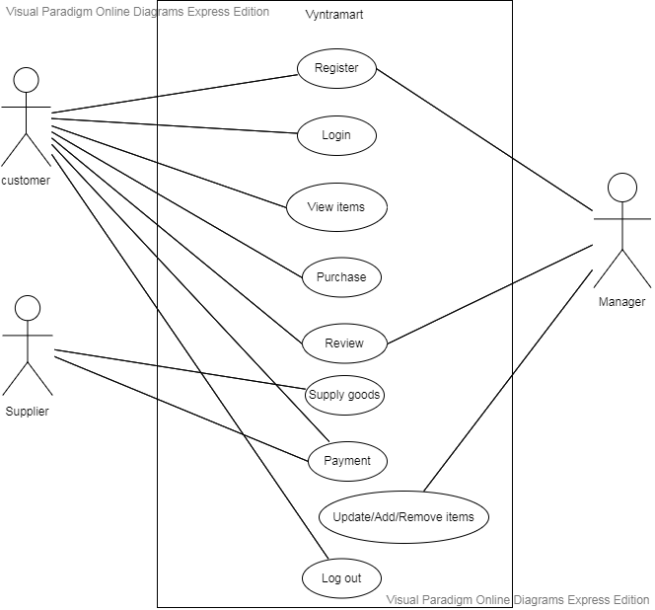

# 

**4 Sequence diagram:**

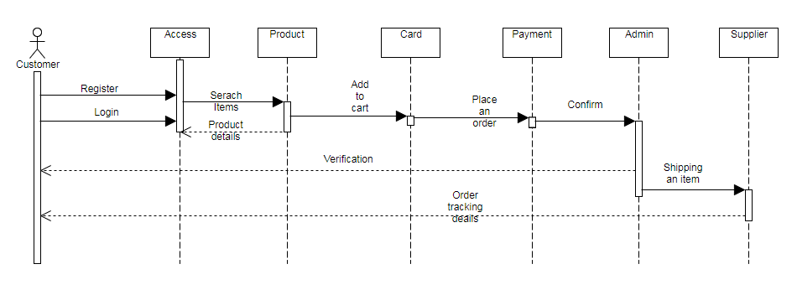

#### 5 Class Design

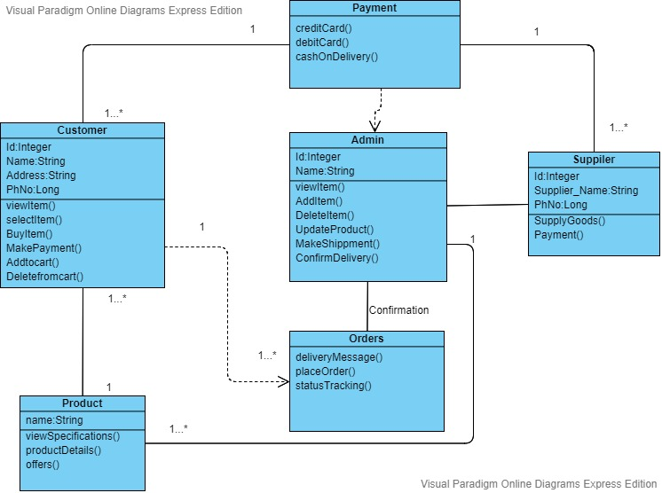

**6 Entity Relationship Diagram**

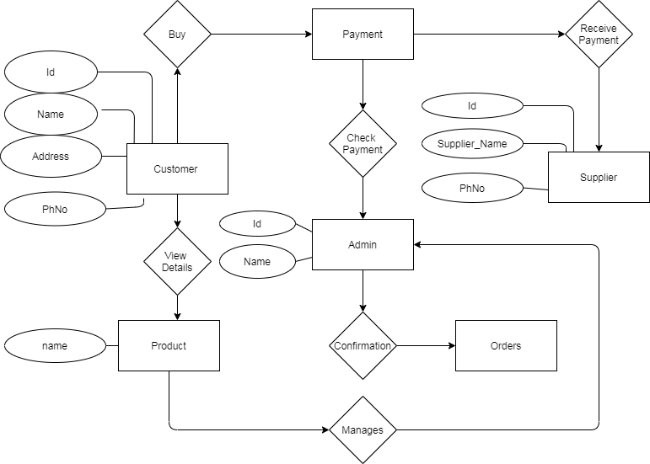

# 

***7 State Chart Diagram***

